***Lyddie***

***Chapter 18 – Charlie At Last***

Lyddie went downstairs into the living room and saw Charlie standing there.  She couldn't believe it.  She just stood and looked at him and then he said "Sister". Lyddie said "Yes, so you've come".

Charlie told her, "I took the railroad car".

Charlie seemed proud of himself and excited that he had taken the railroad.  He smiled, but Lyddie didn't recgonize his smile.  He was the same boy, but somehow she felt like she didn't even know him anymore because it had been so long.

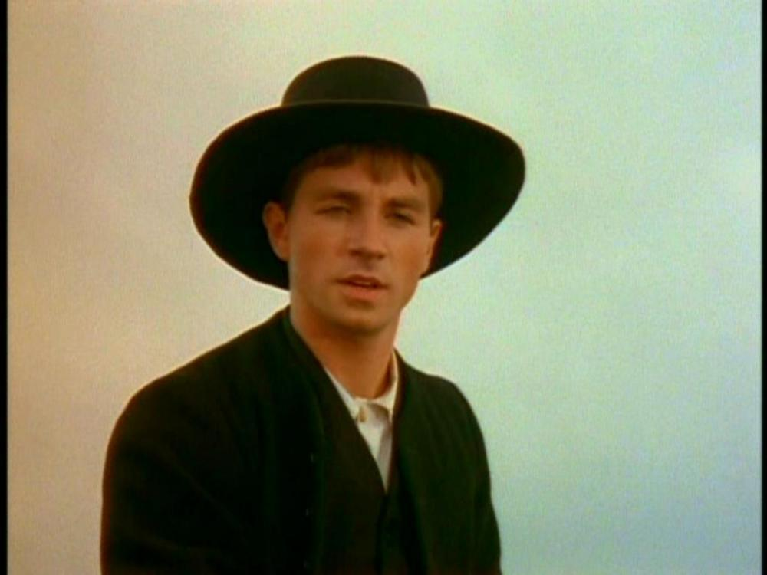

Charlie tells Lyddie that he has some good news.  He tells her that the Phinney's, the people with whom he was staying to work, had taken him on as a full time worker and that they treated him like their own son.

Lyddie said, "But Charlie, you already have a family..." in a sad voice.

Charlie told her that he would never forget that she was his sister but that with the Phinney's he never had to worry about having enough food or having a place to sleep. He said they gave him a really good life.

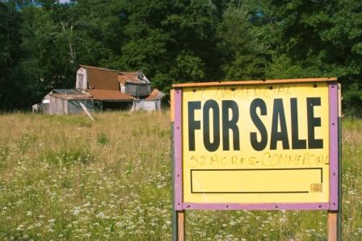

Then, Charlie tells Lyddie that he has even more good news.  The Phinney's want a daughter and have agreed to take Rachel and raise her as if she were their own daughter.

Lyddie couldn't help but think to herself that she didn't want Rachel to go because Rachel was all that she had left in the world.  But, Lyddie knew that it was the right thing to do so she asked Charlie, "When will you leave?"

He said, "Tomorrow morning I will come and get her after breakfast".

Then Charlie began to tell Lyddie about the farm.  He said that Uncle Judah was determined to sell and that there was nothing he could do to stop it.  Then he told her that Uncle Judah would also keep all of the money they got from selling the farm as payment for having taken care of Mama.



Lyddie felt so sad.  She knew that Rachel was leaving and their home was all but gone.  Then, Charlie told her he had a letter for her from Luke Stevens. Lyddie was confused, but took the letter and put it in her pocket to look at later.

Then, Charlie left and Lyddie walked upstairs to see Rachel.  Rachel was asleep and Lyddie took her Bible and wrapped it up with a note for Rachel.  As Lyddie wrapped it and wrote the note she cried.  She knew Rachel leaving was for the best, but she couldn't help but feel so alone.



Rachel had been gone for almost a week when she finally realized she still had not opened the letter Charlie had given her from Luke Stevens.  Lyddie opened the letter and it said,

Dear Lyddie Worthen,

I know that you have heard by now that I can do nothing to convince Uncle Judah not to sell the farm.  However, I have spoken to Charlie and I think that I need to tell you how I am feeling.  I was thinking that I might be able to buy your farm and have you come back to live there are my wife. Forgive these bold words, but I do look forward to hearing your answer.

Love,

Luke Stevens



After reading the letter Lyddie felt angry.  Why did he think she would marry him? Lyddie had not been a slave for a long time and certainly did not want to feel like a slave to any man.  Lyddie tore the letter to shreds and then, to her own surprise and amazement, burst into tears.